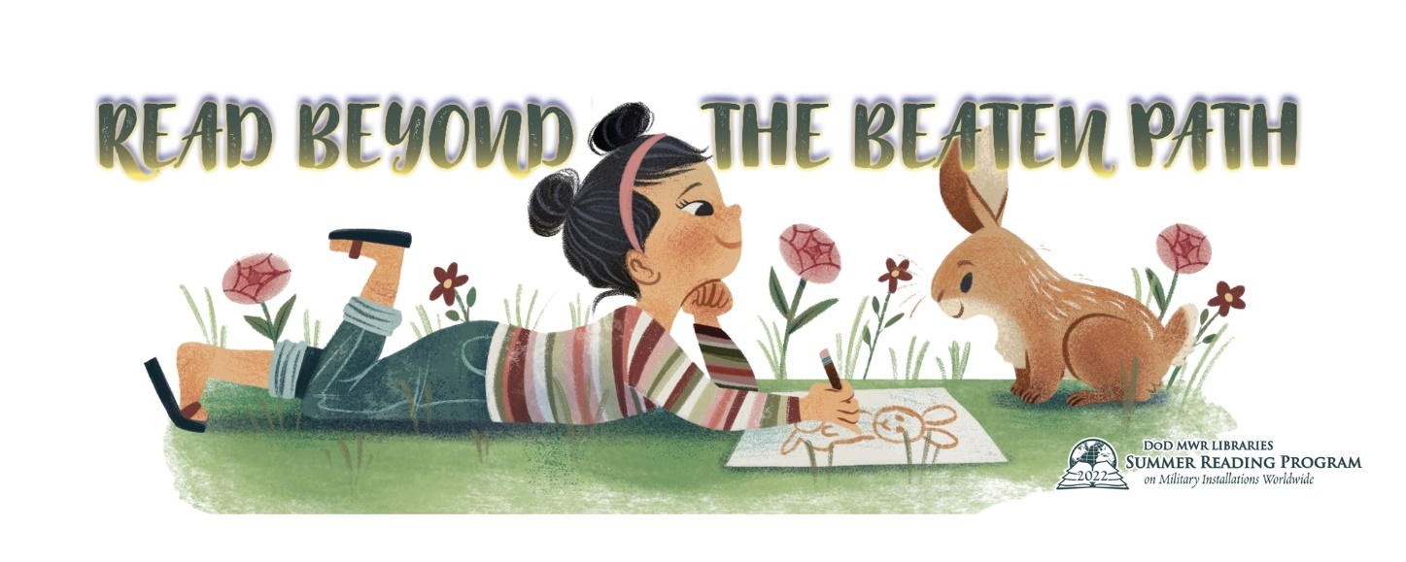
SUMMER READING PROGRAM SUMMER 2022
CASE-HALSTEAD LIBRARY, CARLYLE IL
THURSDAY, JUNE 9 – THURSDAY, JULY 21
Sign-ups begin June 9 at the library!
Then throughout June and July read, read, read to win weekly prizes and enter the Grand Prize Drawings!
Summer Reading Acts for 2022:
June 16: The Rusty Pliers Show—down home ventriloquist fun!—2pm
June 23: Professor Bubbles Science Show—Bubbles and fun!—2pm
June 30: White Rabbit Magic Show—a real rabbit and hat!—2pm
July 7: Independence Day Week break
July 14: The Rope Warrior—rope tricks a great show!—2pm
July 21: Alan Kazam Magic Show—fun for the whole family!—2pm
We will draw for grand prizes including Six Flags Tickets, Passes to the Magic House and Gift Certificates for the St. Louis Zoo on July 21 after the show! For adults we will be drawing for St. Louis Cardinals Gift Certificates and Botanical Gardens Gift Certificates!

